Outcomes of Early Coronary Angiography or Revascularization After Cardiac Surgery
Outcomes of Early Coronary Angiography or Revascularization After Cardiac Surgery
Vikram Sharma ¹, Kevin Chen ², Shehab A R Alansari ¹, Beni Verma ¹, Edward G Soltesz ³, Douglas R Johnston ³, Michael Zhen-Yu Tong ³, Eric E Roselli ³, Per Wierup ³, Gösta B Pettersson ³, A Marc Gillinov ³, Stephen G Ellis ⁴, Conrad Simpfendorfer ⁴, Eugene H Blackstone ⁵, Samir Kapadia ⁴, Lars G Svensson ³, Faisal G Bakaeen ⁶
Affiliations
- Department of Hospital Medicine, Cleveland Clinic, Cleveland, Ohio.
- Department of Internal Medicine, Cleveland Clinic, Cleveland, Ohio.
- Department of Thoracic and Cardiovascular Surgery, Cleveland Clinic, Cleveland, Ohio.
- Department of Cardiovascular Medicine, Cleveland Clinic, Cleveland, Ohio.
- Department of Thoracic and Cardiovascular Surgery, Cleveland Clinic, Cleveland, Ohio; Department of Quantitative Health Sciences, Cleveland Clinic, Cleveland, Ohio.
- Department of Thoracic and Cardiovascular Surgery, Cleveland Clinic, Cleveland, Ohio. Electronic address: bakaeef@ccf.org.
Background: Early coronary ischemic events are uncommon after cardiac surgery, with little known about their management or associated outcomes. We evaluated clinical outcomes of patients undergoing coronary angiography ± percutaneous coronary intervention or redo coronary artery bypass grafting for suspected coronary ischemia within 3 weeks after index cardiac surgery.

Methods: This is a retrospective observational study based on data from 53,287 patients who underwent cardiac surgery at our institution (1996-2017); 180 patients (0.34%) satisfied the inclusion criteria. The primary outcome was 1-year all-cause mortality. Statistical evaluation involved χ2, analysis of variance, Kaplan-Meier, and receiver operating characteristic curve analyses.

Results: Most coronary angiography ± percutaneous coronary intervention and redo coronary artery bypass grafting procedures occurred in the first 2 weeks after index cardiac surgery. Patients presenting with ST elevation myocardial infarction (STEMI)/non-STEMI had the lowest 1-year mortality (13.5%), followed by patients with ventricular tachycardia/fibrillation (28.1%), and patients with non-ventricular tachycardia/fibrillation arrest or hemodynamic instability alone the worst (38.6%) (χ2 = 17.3, P = .001). Peak troponin T level after cardiac surgery was strongly predictive of 1-year mortality (area under the curve, 0.74; 95% confidence interval, 0.65-0.84; P < .001) but did not predict the presence of coronary compromise. For acute graft failure, 1-year mortality was better with percutaneous coronary intervention (18.2%) than redo coronary artery bypass grafting (23.5%) or no indicated/feasible intervention (29.2%).

Conclusions: Although suspected myocardial ischemia requiring coronary angiography or intervention early after cardiac surgery was rare, mortality was high, particularly in presentations other than STEMI/non-STEMI. In patients with overt signs and symptoms of myocardial ischemia after index cardiac surgery, troponin T was not a reliable marker of underlying coronary or graft obstruction but was a robust predictor of 1-year mortality.
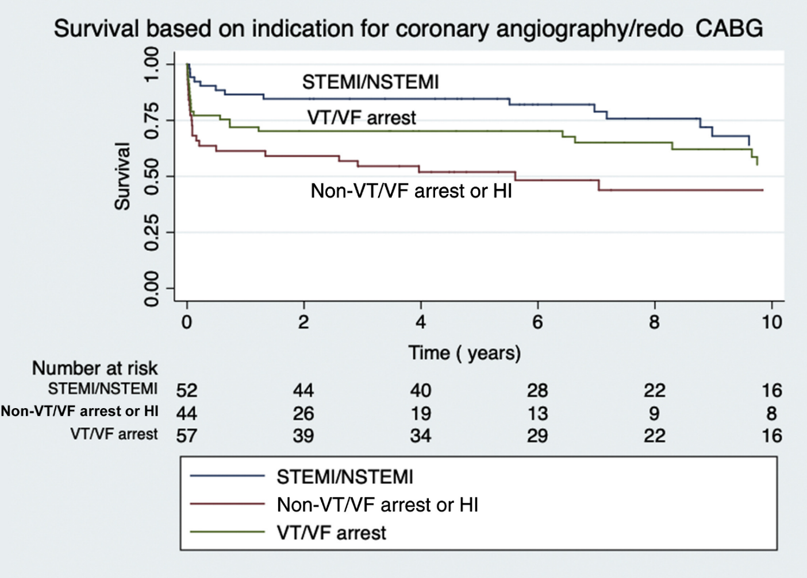
Fig 1. Kaplan-Meier curves showing better survival in patients with ST elevation myocardial infarction (STEMI)/non-STEMI (NSTEMI) or ventricular tachycardia (VT)/ventricular fibrillation (VF) arrest compared with non-VT/VF arrest or hemodynamic instability (HI) alone when undergoing coronary angiography and/or revascularization for a suspected ischemic event within 3 weeks after open heart surgery. (CABG, coronary artery bypass grafting.)

Published:
Outcomes of Early Coronary Angiography or Revascularization After Cardiac Surgery. The Annals of Thoracic Surgery Volume 111, Issue 5, May 2021, Pages 1494-1501
Presented at the Poster Session of the Fifty-sixth Annual Meeting of The Society of Thoracic Surgeons, New Orleans, LA, Jan 25-28, 2020.

