Acute left atrial appendage thrombus formation during MitraClip procedure
Vikram Sharma, Phillip A Horwitz, James D Rossen, Ramzi N El Accaoui
Department of Cardiology, Division of Internal Medicine
University of Iowa Hospitals and Clinics

Corresponding author
Vikram Sharma
Department of Cardiovascular medicine
University of Iowa Hospitals and Clinics
Address 4223 RCP
200 Hawkins Drive
Iowa City, IA 52242
Phone 3193848001
Email: vikram-sharma@uiowa.edu
Fax: 319-353-6343

Abstract:
We present a case of a 75-year-old patient who developed acute left atrial appendage thrombus immediately following MitraClip deployment despite adequate intra-procedural anticoagulation. Patient was managed with enoxaparin to warfarin bridging with no obvious thromboembolic events on follow-up. Attention to anticoagulation is important to reduce thromboembolic risk during MitraClip deployment.
Case Report:
We present the case of a 75-year-old male with a past medical history of severe symptomatic mitral valve regurgitation, severe ischemic cardiomyopathy and history of AV node ablation with cardiac resynchronization therapy for permanent atrial fibrillation. His CHA2DS2-VASc score was 5. He was noted to have an eccentric posteriorly directed mitral regurgitation jet due to mal-coaptation of leaflets. The mitral regurgitation was presumed to be functional in etiology secondary to the severe left ventricular dysfunction. His Society of Thoracic Surgeons mortality risk was 6% with mitral valve replacement and 3.6% with valve repair. After review by the multidisciplinary valve team, he was thought to be a suitable candidate for MitraClip (Abbott Vascular) procedure due to elevated surgical risk, poor functional status, and severely impaired left ventricular function. Prior to MitraClip, he was on aspirin and warfarin due to a history of coronary artery disease and atrial fibrillation. Warfarin was held for the procedure and his INR was 1.2 on the day of procedure.
Patient had no prior history of left atrial appendage thrombus (LAA) thrombus. Before the procedure, transesophageal echocardiogram showed no evidence of LAA thrombus (Figure 1). LAA emptying velocity by spectral Doppler was reduced. A G4 NTRw MitraClip was successfully deployed with immediate reduction in mitral regurgitation from severe to mild. At the time of the trans-septal puncture, patient received prompt systemic anticoagulation with heparin. He was given a total of 13,000 Units aiming to maintain activated clotting time (ACT) > 250 seconds (reference range 74-137 seconds) during procedure. ACT was 235 seconds after initial bolus of heparin; subsequent readings were 274, 257, and 246 seconds. Mean mitral valve gradient did not change significantly, it was 3 mm Hg post procedure compared to 2 mm Hg prior to procedure. Spontaneous echo-contrast was noted in the left atrium and the left atrial appendage immediately after the deployment of the MitraClip, suggestive of stasis secondary to sudden reduction in mitral regurgitation (Figure 2). Few minutes later, the spontaneous echo-contrast continued to thicken leading to the formation a well-defined thrombus in the left atrial appendage (Figure 3 and Video 1).
At the end of the case, right femoral vein sheath was removed, and the access site closed with a purse-string suture. Typically, protamine is administered to reverse ACT prior to sheath removal. However, in this case, it was not given due to the formation of acute LAA thrombus and the risk of propagation. Therapeutic dose enoxaparin (1 mg/kg) was given immediately after the procedure and patient was started on warfarin the same day. He subsequently underwent enoxaparin to warfarin bridging. He did well and was discharged home without any complications. He had an uneventful recovery. Aspirin and warfarin were continued. He had no post procedural complications, including no stroke or major bleeding at 45-day follow-up.
As far as the authors are aware, this is the first case of acute left atrial appendage thrombus in the immediate post-procedural setting, during MitraClip placement reported from the United States.
Discussion
Percutaneous valve interventions have significantly expanded the treatment options for severe valve disease, particularly in high-risk patients. Percutaneous mitral valve repair with MitraClip has become a commonly performed procedure for the management of severe mitral regurgitation in high-risk patients. Several clinical trials have shown that MitraClip is a safe alternative compared to surgical mitral valve repair or replacement for treatment of severe mitral regurgitation in selected patients (1,2). Patients with mitral valve disease have an increased risk of developing atrial fibrillation. However, the presence of atrial fibrillation does not adversely affect outcomes in patients undergoing MitraClip intervention, even though patients with atrial fibrillation are more likely to have additional comorbidities and more advanced valve disease (3). Patients with atrial fibrillation do have an elevated risk of left atrial appendage thrombus. Intra-procedural transesophageal echocardiography plays a crucial role in the success of MitraClip procedure (4). At the same time, it can identify acute complications, such as formation of pericardial effusion or acute intracardiac thrombus. Overall, the incidence of stroke in patients undergoing MitraClip remains low, ranging from 0.7 -2.6 % at 30 days (5). However, there are several factors related to the procedure that present a risk for intracardiac thrombus formation intra-procedurally including need for trans-septal puncture, exposure of the MitraClip sheath/delivery system to the blood stream and the clips themselves are foreign bodies that can develop a thrombus over time. Hence anticoagulation during the procedure and dual antiplatelet therapy for 6 months afterwards are the standard practice, though there are limited studies guiding this practice. Patients with atrial fibrillation undergoing MitraClip, as well as patients with other indications for anticoagulation, have been managed with continuation of their oral anticoagulation and single antiplatelet agent. There are handful of case reports of acute thrombus formation during the MitraClip procedure in the left and right atria, particularly at the site of trans-septal puncture, as well as on the clip delivery system/guide catheter and the MitraClip itself (6,7). Acute thrombus formation in the LAA immediately following MitraClip placement is rare. The authors identified only one prior case report of acute LAA thrombus formation immediately after MitraClip placement, which was reported from Germany in 2018 (8). In that reported case, patient had severe left ventricular impairment (left ventricular ejection fraction 20%) and history of atrial fibrillation, similar to the current case. Also, both patients had low left atrial appendage emptying velocities. In the previously reported case, the authors performed a thromboelastogram on blood sampled from left atrium directly, showing gain of thrombogenicity. There were no instances of overt clinical thromboembolism in both cases. Both patientswere managed with warfarin and bridging with low molecular weight heparin. In both these cases, thrombus formation was preceded by the development of spontaneous echo-contrast. Thus, blood stasis likely plays an important role. In another case reported from Japan in 2017, left atrial appendage thrombus was noted on follow-up transesophageal echocardiogram 1 week after MitraClip (9). This patient also had reduced left ventricular ejection fraction and history of atrial fibrillation. Patient was on warfarin and was maintained at a higher INR target of 2.5-3 with resolution of thrombus after 5 weeks. No systemic embolization was noted at 1 year in that reported case. In a recent study, patients were noted to have reduced incidence of stroke (0.2%) with oral anticoagulation with warfarin for 30 days after MitraClip compared to dual antiplatelet therapy (10). This indicates that selective use of oral anticoagulation, at least for short period of time (4-6 weeks) following MitraClip, rather than dual antiplatelet therapy, should be considered for patients with risk factors for left atrial thrombus formation such as a history of atrial fibrillation, severely impaired left ventricular systolic dysfunction, low appendage velocity and elevated CHA2DS2-VASc score.

REFERENCES
1. Feldman T, Kar S, Rinaldi M et al. Percutaneous mitral repair with the MitraClip system: safety and midterm durability in the initial EVEREST (Endovascular Valve Edge-to-Edge REpair Study) cohort. J Am Coll Cardiol 2009;54:686-94.
2. Whitlow PL, Feldman T, Pedersen WR et al. Acute and 12-month results with catheter-based mitral valve leaflet repair: the EVEREST II (Endovascular Valve Edge-to-Edge Repair) High Risk Study. J Am Coll Cardiol 2012;59:130-9.
3. Herrmann HC, Gertz ZM, Silvestry FE et al. Effects of atrial fibrillation on treatment of mitral regurgitation in the EVEREST II (Endovascular Valve Edge-to-Edge Repair Study) randomized trial. J Am Coll Cardiol 2012;59:1312-9.
4. Silvestry FE, Rodriguez LL, Herrmann HC et al. Echocardiographic guidance and assessment of percutaneous repair for mitral regurgitation with the Evalve MitraClip: lessons learned from EVEREST I. J Am Soc Echocardiogr 2007;20:1131-40.
5. Nusca A, Bressi E, Colaiori I, Miglionico M, Di Sciascio G. Antiplatelet therapy in valvular and structural heart disease interventions. Cardiovasc Diagn Ther 2018;8:678-693.
6. Bilge M, Saatci Yasar A, Ali S, Alemdar R. Left atrial spontaneous echo contrast and thrombus formation at septal puncture during percutaneous mitral valve repair with the MitraClip system of severe mitral regurgitation: a report of two cases. Anadolu Kardiyol Derg 2014;14:549-50.
7. Huntgeburth M, Muller-Ehmsen J, Brase C, Baldus S, Rudolph V. Thrombus formation at the MitraClip system during percutaneous mitral valve repair. JACC Cardiovasc Interv 2014;7:e111-2.
8. Glatthaar A, Seizer P, Patzelt J, Langer H, Schreieck J, Gawaz M. Formation of a left atrial thrombus during percutaneous mitral valve edge-to-edge repair induced by acute reduction of mitral regurgitation. J Cardiol Cases 2018;17:33-35.
9. Amaki M, Kataoka Y, Kanzaki H et al. Subacute Left Atrial Thrombus Formation After Percutaneous Edge-to-Edge Mitral Valve Repair for Functional Mitral Regurgitation. Circ J 2018;82:1712-1713.
10. Geis N, Raake P, Kiriakou C et al. Temporary oral anticoagulation after MitraClip - a strategy to lower the incidence of post-procedural stroke? Acta Cardiol 2020;75:61-67.

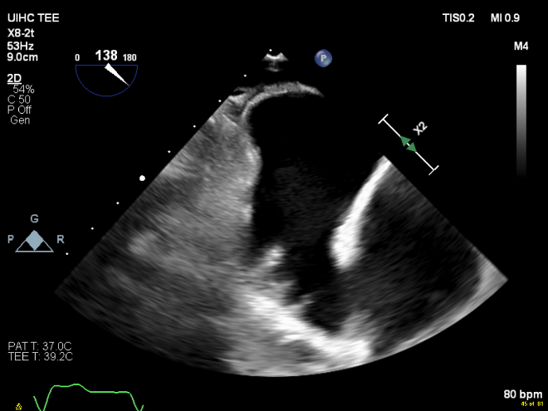
Figure 1. Pre-procedural transesophageal echocardiogram showing no evidence of LAA thrombus.
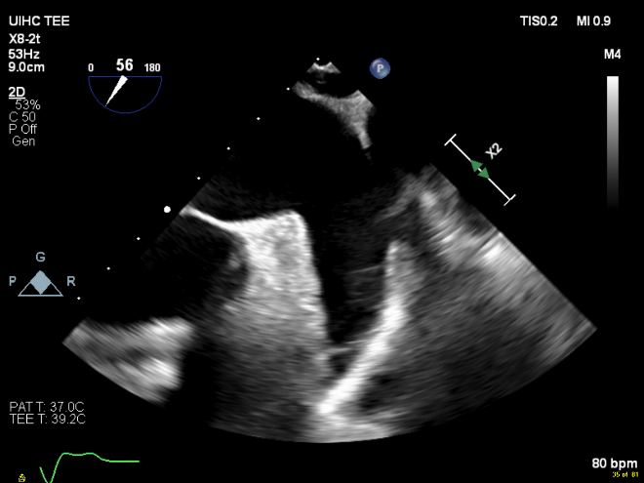

Figure 2. Spontaneous echo-contrast in the left atrium and LAA immediately after MitraClip deployment.
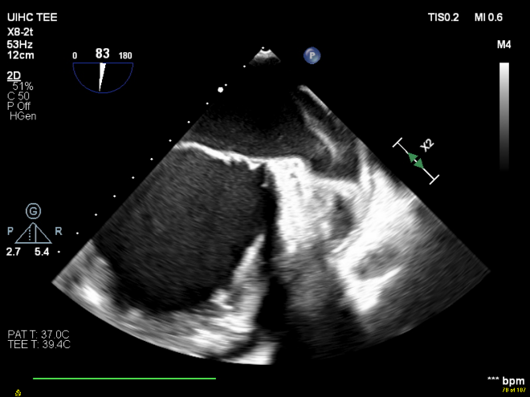

Figure 3. Well-formed thrombus in the LAA after MitraClip deployment.
